ICT Express in 2020

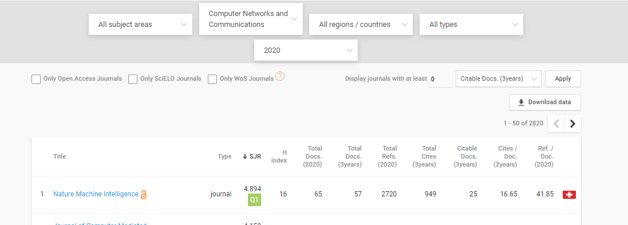

Total Journals = 2820

10% = 2820/10 = 282 OR

Total Journals = 2820

And ICT Express on 101

%age = (101/2820)\*100 = 3.58 %, so under Tier 1(Top 10% )

